- Design and Build Instructions for a Home Made Potters Wheel

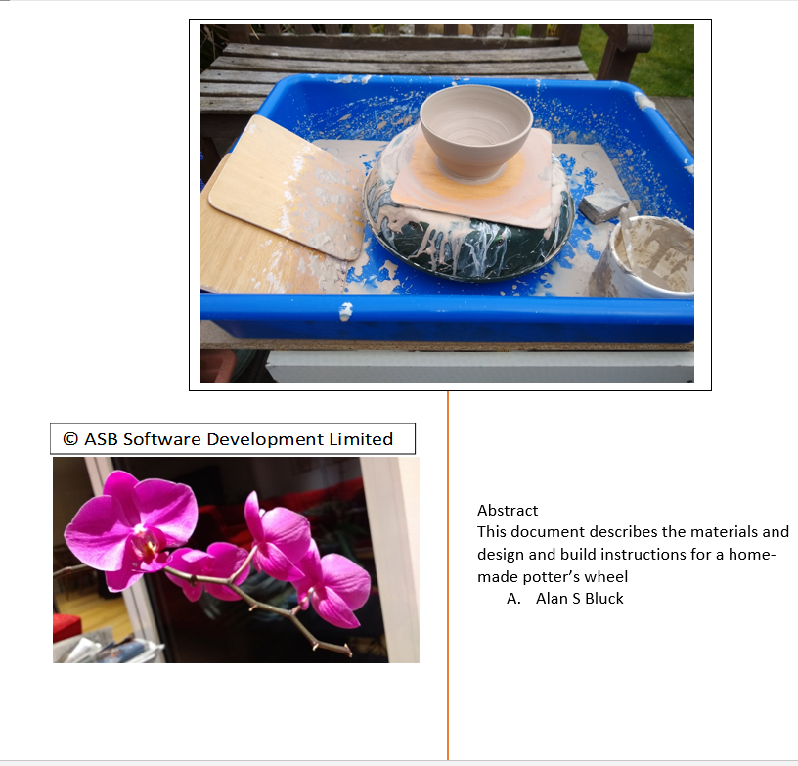

Contents
- Design and Build Instructions for a Home Made Potters Wheel 1
Copyright 2
Molecular Biology Installations - ASB Software Development Limited Publications 2
FREE DOWNLOADS 2
IBM Installations - ASB Software Development Limited Publications 3
FREE DOWNLOADS 3
Contact Details 5
Bill of Materials required for the Potter’s Wheel 5
Cordless Electric Drill for driving the wheel 5
MDF 18mm thick x 500mm x 570 mm x 5 shelves 5
Plastic Oven Rack Soaking Tray 6
(eg from Lakeland) 6
Plant Saucer 30cm drip tray (used for wheel) 7
Screws, Coach Bolts and Headboard metal brackets 8
The Wheel Head 10
Foot Pedal Design 12
Hinged Wooden clamp, washer and butterfly nut 13
Hinges and Handles for Foot Pedal and carrying handles 14
Appendix - Pictures of the Completed Potter’s Wheel 15

Copyright

Copyright © by ASB Software Development Limited All rights reserved.

This book or any portion thereof may not be reproduced or used in any manner whatsoever without the express written permission of the publisher except for the use of brief quotations in a book review or scholarly journal.
First Printing: ISBN 978-0-244-87898-6 , https://asb-software.com/potters-wheels/

Molecular Biology Installations - ASB Software Development Limited Publications

FREE DOWNLOADS
https://doi.org/10.13140/RG.2.2.26844.33925
Installation of UCSF Chimera 1.4
https://doi.org/10.13140/RG.2.2.18753.10083
EMBOSS Analysis Of COVID-19 GENOME SEQUENCE AND INSTALLATION ON WINDOWS 10-and RHEL 8.0

IBM Installations - ASB Software Development Limited Publications
https://bookauthority.org/books/new-ibm-watson-ebooks?t=p7zh09&s=award&book=B093ZNJY9L

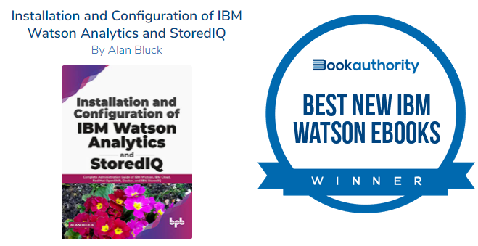
https://www.amazon.co.uk/dp/B093ZNJY9L?linkCode=gs2&tag=uuid07-21
Installation and Configuration of IBM Watson Analytics and StoredIQ

FREE DOWNLOADS
https://doi.org/10.13140/RG.2.2.34136.93449
Audit System setup on an IBM DB2 11.5 Database on RedHat Linux RHEL 8.0 using the Go Language
https://doi.org/10.13140/RG.2.2.29470.69441
Upgrade of IBM FileNet systems from DB2 10.5 FP 10 to latest DB2 11.5 version on RedHat RHEL 8.0
https://doi.org/10.13140/RG.2.2.15264.12807
Jupyter notebook and its Docker Container Installation on Linux RedHat RHEL 8.0 using VMware 15.5.2
https://doi.org/10.13140/RG.2.2.27286.50240
IBM Cognos Analytics 11.1.4 Installation - Linux Appendix for Fix for Zlib and Configuration for RHEL 8.0
https://doi.org/10.13140/RG.2.2.11682.38089
IBM Case Analyzer 5.5 Installation and Configuration On RHEL 8.0 for Case Monitor Dashboard 5.3.3 plugin
https://doi.org/10.13140/RG.2.2.35304.83208
IBM Content Search Services 5.5.3 Installation on CENTOS 8.0 and Configuration on RHEL 8.0
https://doi.org/10.13140/RG.2.2.16987.52008
Importing Case Manager solution Auto Claims example into Case Manager 5.3.3 on RHEL 8.0

https://doi.org/10.13140/RG.2.2.27057.94561
IBM CEBI Content Engine Bulk Import Document Batch Tool Example on Linux Centos 8
https://doi.org/10.13140/RG.2.2.26048.69128
Installation of LibreOffice 6.3.3.1 on Linux Centos 8.0
https://doi.org/10.13140/RG.2.2.12361.49767
IBM Case Manager Preparation of a new Target Object Store in a FileNet P8 Docker Container on CENTOS 8
https://doi.org/10.13140/RG.2.2.11327.66721
IBM Watson Explorer Foundational Components 12.0.3 Installation and Configuration on CentOS Linux 8.0
https://doi.org/10.13140/RG.2.2.12248.44803
Watson Explorer 12.0.3 oneWEX Installation on IBM Cloud CENTOS 8.0 Linux with Docker Containers
https://doi.org/10.13140/RG.2.2.20256.94729
IBM Cloud Private P8 Container CPIT Installation on CENTOS Linux 8.0
https://doi.org/10.13140/RG.2.2.36842.88007
Installation of Eclipse Codewind and Docker Compose on RHEL 8 Linux with IBM Cloud Private CE (Community Edition)
https://doi.org/10.13140/RG.2.2.20160.69129
IBM FileNet P8 Java Development on ECM Cloud Private Container P8 Examples
https://doi.org/10.13140/RG.2.2.27358.18246
IBM Cloud Private P8 Container CPIT Installation on RedHat Enterprise Linux 8.0
https://doi.org/10.13140/RG.2.2.22030.92486
Problem Resolution Procedures For fixing Software Installation Issues
https://doi.org/10.13140/RG.2.2.27345.89440
IBM BAW 18.0 Installation phase1 preprint with install of IBM Workflow Center 8.6.1.19002
https://doi.org/10.13140/RG.2.2.10491.67369
DB2 10.5 Installation on CENTOS 8.0 V1
https://doi.org/10.13140/RG.2.2.33527.57761
IBM Security Directory Services 6.4- Installation on RHEL 8.0
https://doi.org/10.13140/RG.2.2.15007.10408
WebSphere 8.5.5.15 Installation 29-06-2019 on VMWare Workstation Pro 15.1
https://doi.org/10.13140/RG.2.2.15737.83048
IBM BAW 18.0 Installation 18 07 2019 - Install of IBM Security Directory Suite 8.0.1.1 on CENTOS 8 using VMWare Workstation Pro 15.1
https://doi.org/10.13140/RG.2.2.21708.16001
Case Manager 5.3.3 Installation on RHEL 8.0 with Content Navigator 3.0.6
https://doi.org/10.13140/RG.2.2.31489.10082
Installation of Oracle 12C on the Linux operating system
https://doi.org/10.13140/RG.2.2.14590.95049
Content Navigator 3.0.6 Installation on RHEL 8.0_V1.docx
https://doi.org/10.13140/RG.2.2.21170.76480
Content Foundation 5.5.3 Installation on RHEL 8.0_V2.docx
https://doi.org/10.13140/RG.2.2.30401.51048
Case Manager Installation on RHEL 8.0_Preparation.docx

Contact Details
For any queries on this document please contact the author’s email:
alan.bluck@asbsoftware.co.uk

Bill of Materials required for the Potter’s Wheel

Cordless Electric Drill for driving the wheel
Eg Parkside Cordless Drill PABS 20-Li D4 With 2ah Battery Charger Auto Spindle
The important point above is that there must be a screw-in handle on the drill which can be inserted on either side with the hole allowing a 6mm threaded bolt to be screwed through to hold the drill firmly against a metal back plate.
NB Beware of the drills advertised as a bare unit!:
Sometimes, although the picture shows a battery attached, it may be sold as a Bare Unit with no 20 Volt Lithium Battery supplied!
NB Also in my pictures below I used the older Parkside Drill Model PSBS 24 A1 (which I used, but is no longer sold)
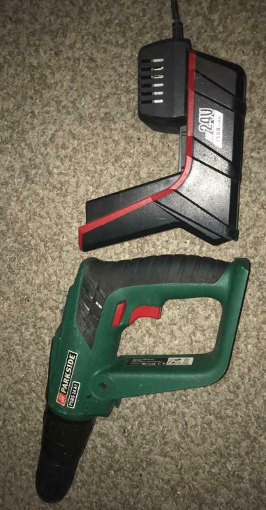
With a 24Volt Lithium battery I used this since it was idle in a box in the garage.
(It might be possible to get one of these second-hand!)

MDF 18mm thick x 500mm x 570 mm x 5 shelves
(From search online for a Kitchen Base Unit with a white matt finish )
NB I first used 18mm x 460mm x 430mm MDF shelving (and this works fine, as a minimum size) as I had these left over in my garage from the kitchen we had installed..
(I have now ordered 5 base kitchen units)
I intend to build another 4 wheels from these 5 units.
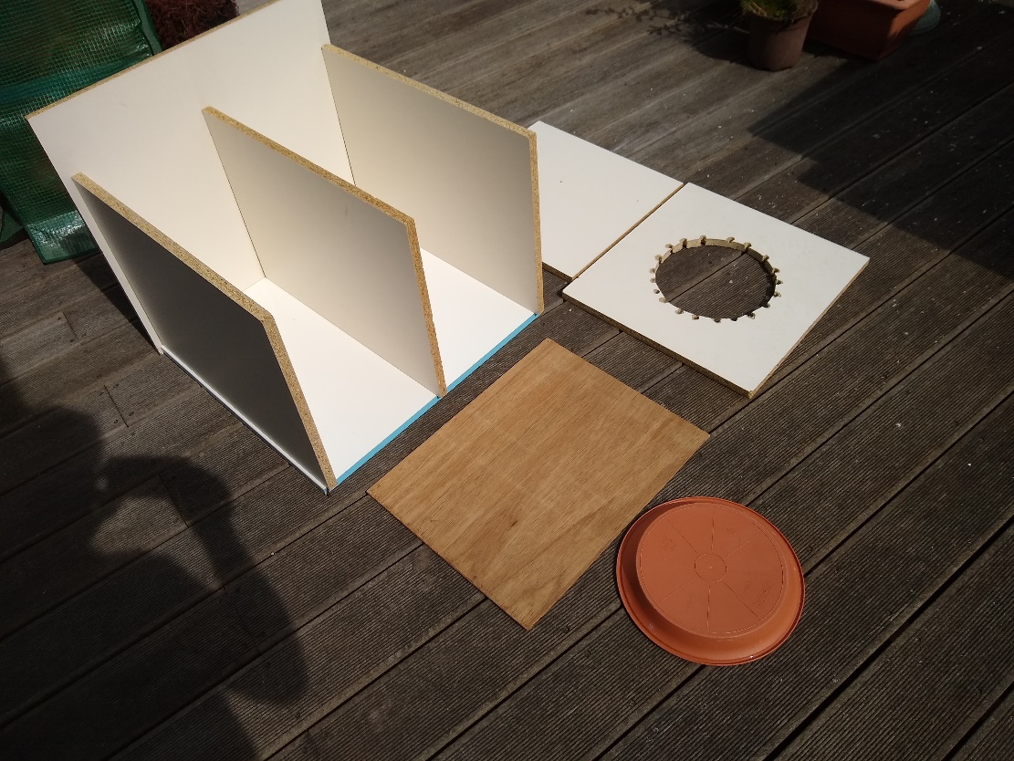
Above are the MDF boards propped in the positions they will be placed in plus the wheel head components.
(The plywood is 6mm Marine ply to be cut into square bats for the wheel)

Plastic Oven Rack Soaking Tray

(eg from Lakeland)
Ref
https://www.lakeland.co.uk/20228/Oven-Rack-Soaking-Tray
Internal – 55 x 40cm x 12cm high (Product number: 20228)

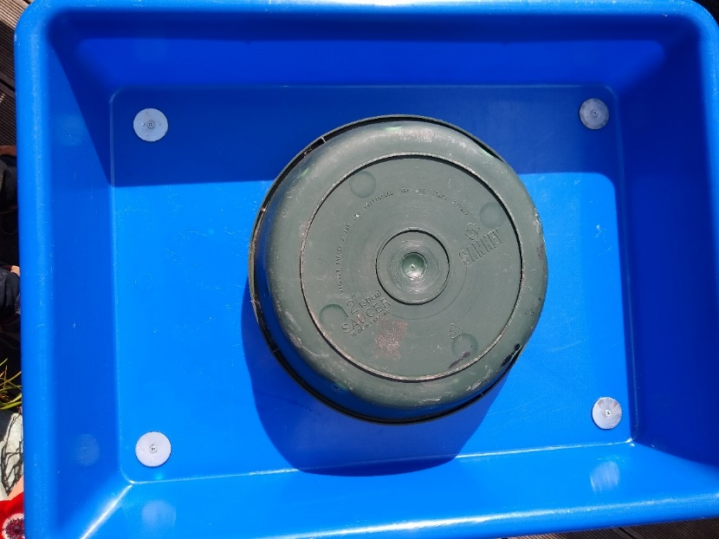
Used as shown for the wheel ‘bowl’ (NB the wheel above is green, but I have selected terracotta in the example below.)

Plant Saucer 30cm drip tray (used for wheel)
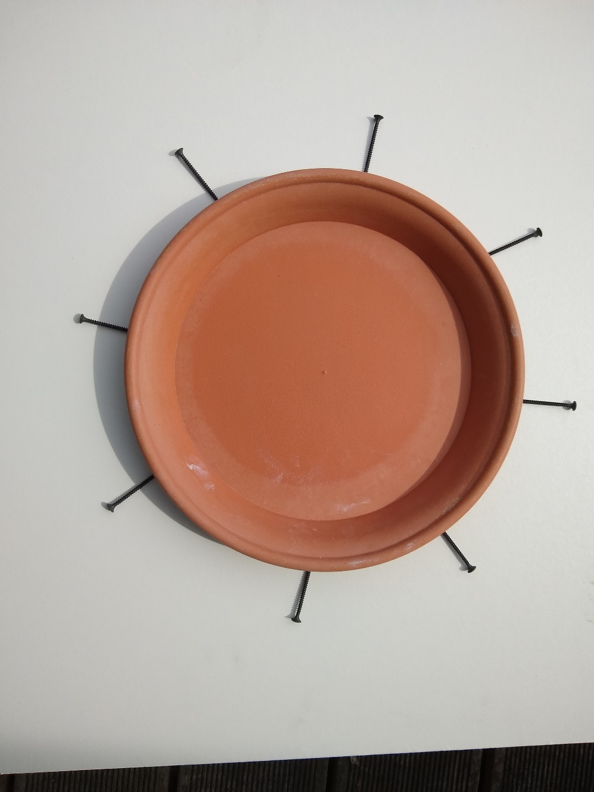

Screws, Coach Bolts and Headboard metal brackets

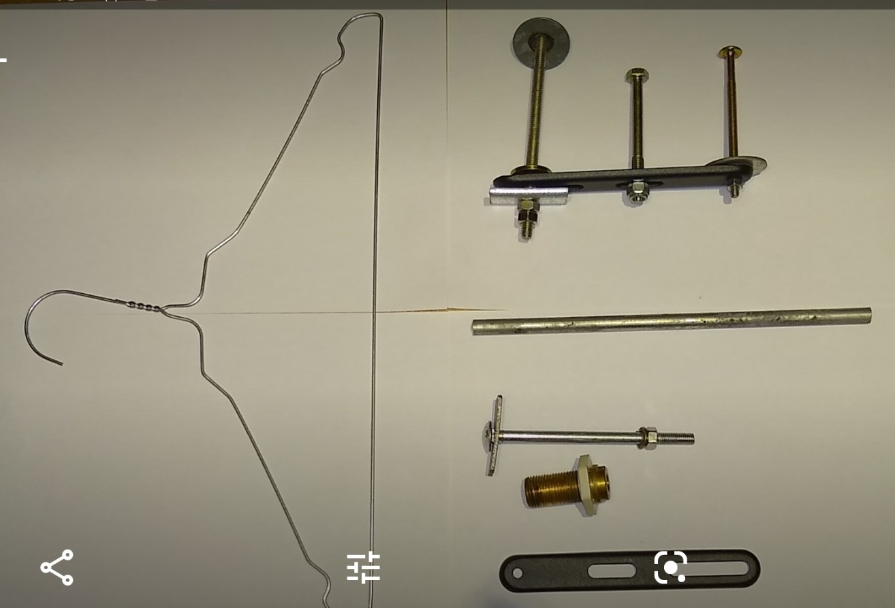
- The coat hanger metal is used to create a spring by wrapping it around a 6mm Iron bar:
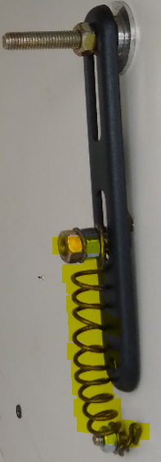
- This spring is used as shown above to counter-load the bolt which presses down as a lever on the drill switch:
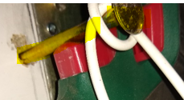
c) This is the bolt on the drill side of the central supporting panel.
d) There is a net-curtain, plastic coated steel flexible wire wrapped as shown around the bolt to pull the drill switch down.
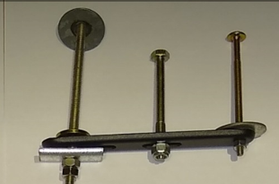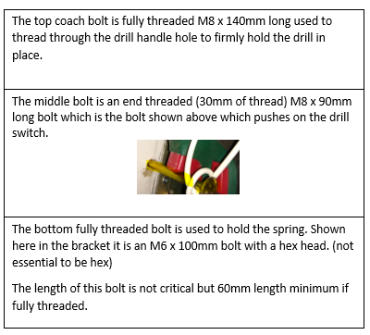

The Wheel Head
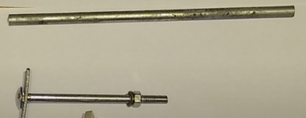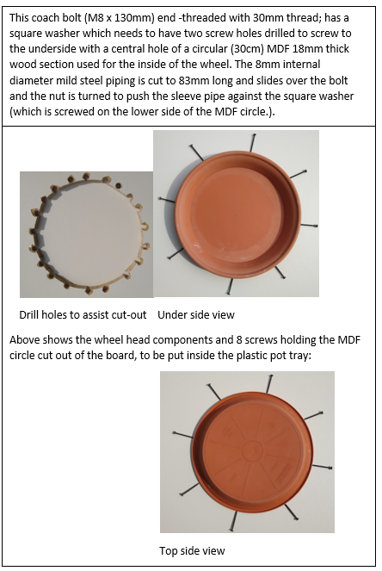

Screws are 50mm cross-head plasterboard dry-wall screws:

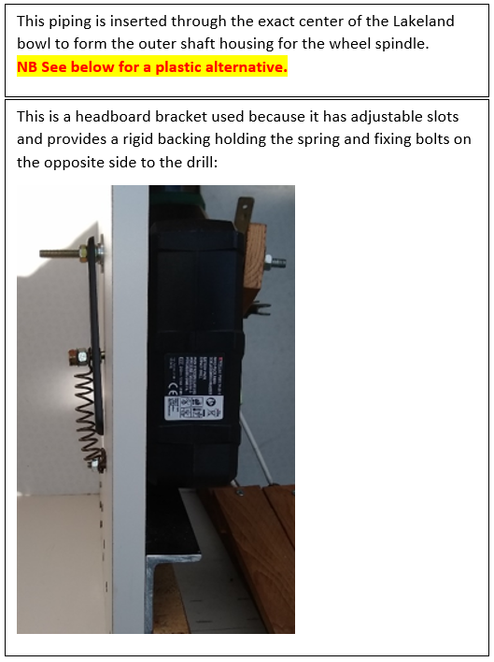
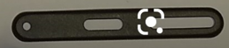

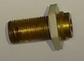
Use water /gas piping end or Search for Water Butt spare parts
25mm (O.D.) Hose Tail
This can be used as an alternative to the brass piping shown above.
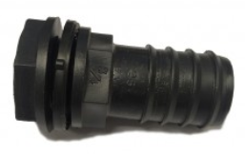

Foot Pedal Design
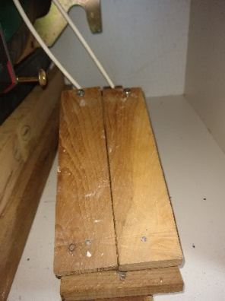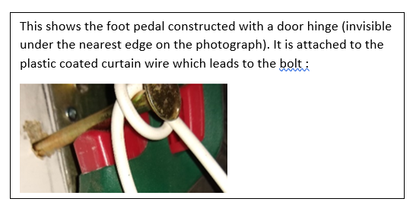
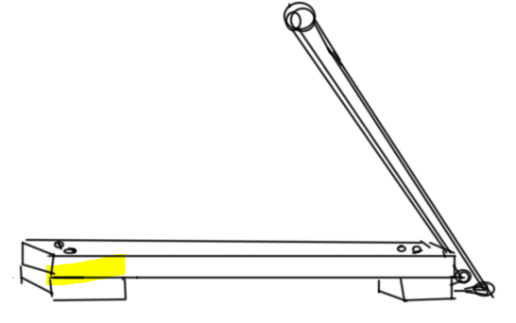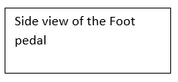
Hinge end Round Hook end
Curtain wire and circular hooks were used to attach the foot pedal to the bolt fixed across the drill switch:
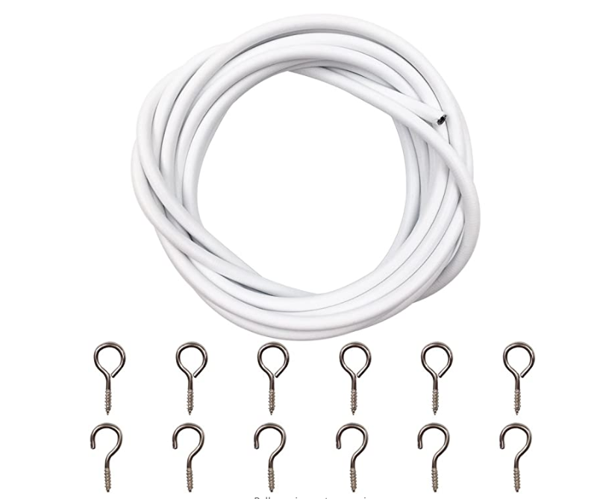

Hinged Wooden clamp, washer and butterfly nut
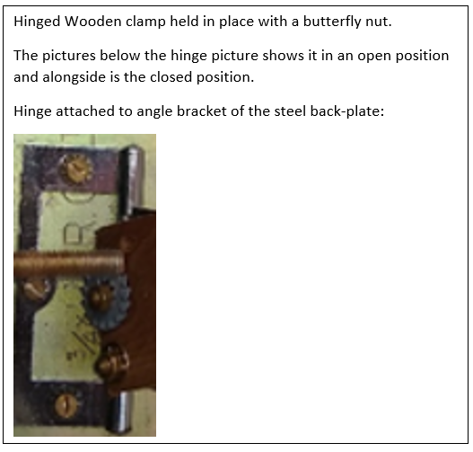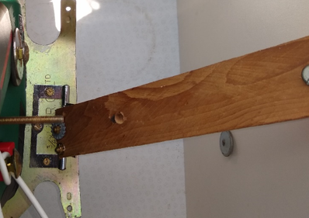
Open clamp Closed clamp with washer and butterfly nut
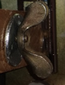
The washer and butterfly nut enlarged.
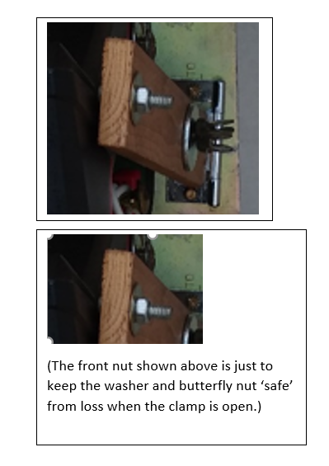

Hinges and Handles for Foot Pedal and carrying handles

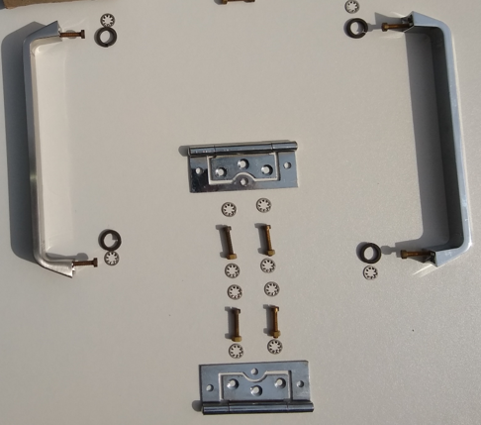

Appendix - Pictures of the Completed Potter’s Wheel

